MiniVIE Demonstration Setup Manual

This manual goes through the process necessary to download the MiniVIE open-source project code package and run the MiniVIE Demonstration completely.

User Manual Table of Contents:
Section I: Importing MATLAB Code………………………………….page 2
Section II: Training Setup …………………………………………………page 6
Section III: Training…………………………………….……………………..page 13
Section IV: Running the MiniVIE Demonstration………………..page 17

Section I: Importing MATLAB Code
This section details how to extract code from the internet and import it to MATLAB.
Note: While steps 1-21 are specific to the MiniVIE Demonstration, they can be applied to any download of files from the internet imported into MATLAB.
- Open up a web browser and insert the link <http://tortoisesvn.net/downloads.html>.
- Select the appropriate size download for the computer:
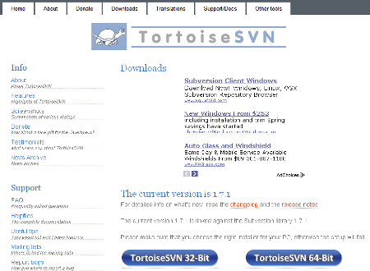
- Download Tortoise SVN.
- After the download is finished, open up My Documents:
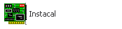
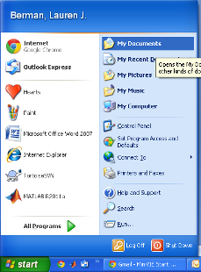
- Select the Downloads folder.
- Open the Tortoise SVN file and click Run.
- Complete the installation process by following the instructions provided.
- Open My Computer.
- Select the C Drive (C:).
- Create a folder called usr:
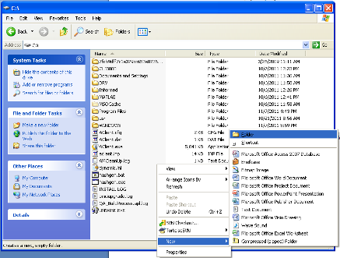
- Create a folder called Myopen, in the usr folder.
- Right click the Myopen folder.
- Select SVN Checkout:
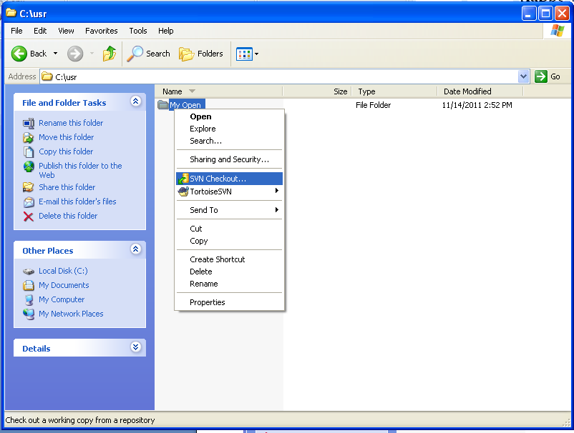
- In the dropdown box titled URL of Repository, insert the website the code is being imported from (eg. http://myopen.googlecode.com/svn/trunk/ is the website for the MiniVIE Demonstration project).
Note: If you are a developer, enter the source directory using https, as in: http://myopen.googlecode.com/svn/trunk/
You will be prompted for your username and GoogleCode (randomly generated) password when you check in changes
- In the dropdown box titled Checkout Directory, type the file path if it’s not already selected (eg. C:\usr\Myopen).
- Then select OK:
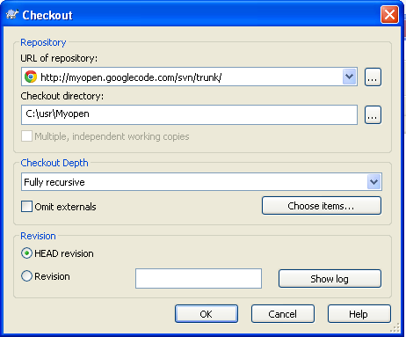
- Files should immediately begin downloading:
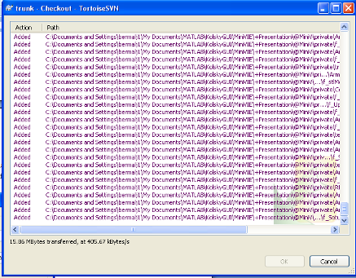

- When the SVN checkout is finished, select OK:
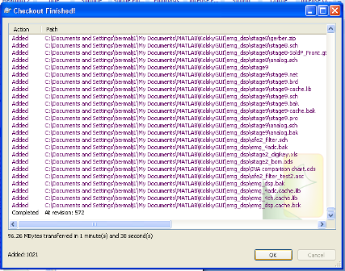
21. Open up the file path C:/usr/MyOpen to insure the code was successfully transferred (there should be a list of folders as below):
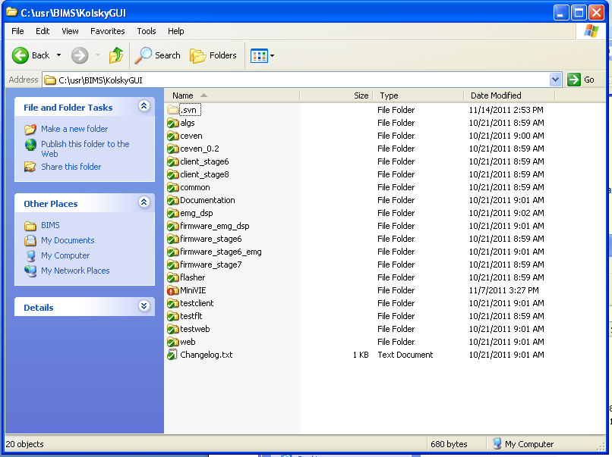

Section II: Training Setup

This section details how to setup the proper configuration for the MiniVIE Program to run training.

- Open MATLAB:
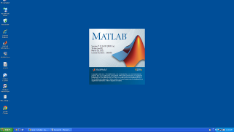
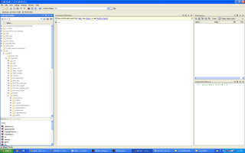
- S

elect File and then select Open:
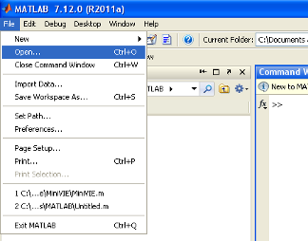
- Open the folder where the previously downloaded files were stored (C:\usr\Myopen).
- Select the MiniVIE folder:
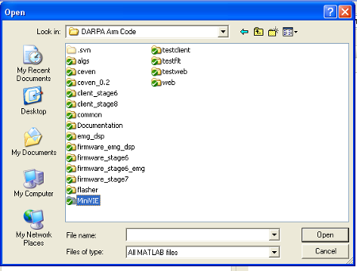
- Next select the file MiniVIE.m:
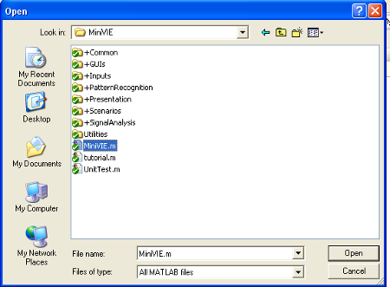

- An editor window should open with the MiniVIE file:
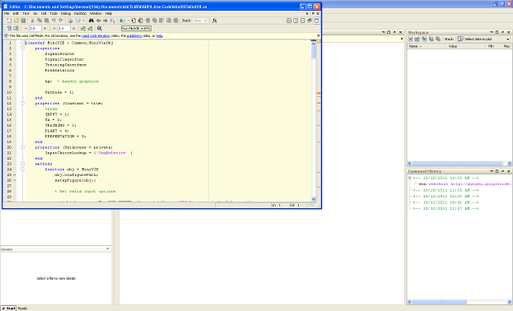
- Select the Run button:
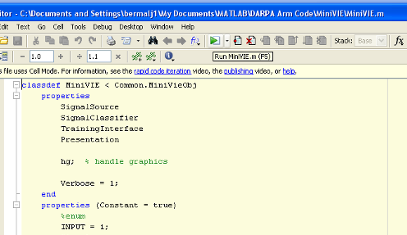

- A window titled MiniVIE Configuration Utility will open with the settings for the MiniVIE program:
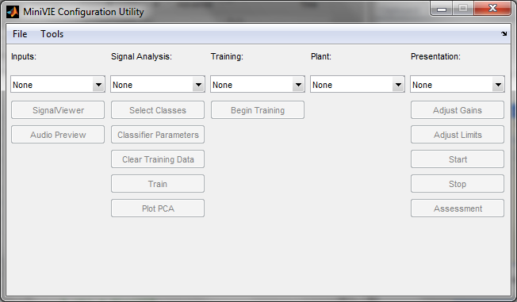

- In the Inputs drop-down menu, select EMG Simulator:
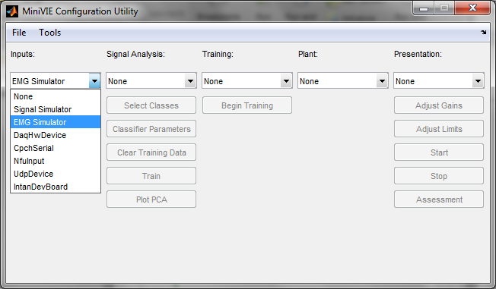
- A EMG Simulator dialogue window should open.

- While the user is in this selected open window, pressing any of the following keys will cause a number to appear as the current pattern: keys a, s, d, f, q, w, e, r.
(Key: a) (Key: r)
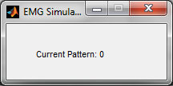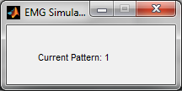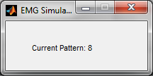

- Under Signal Analysis, select LDA Classifier:
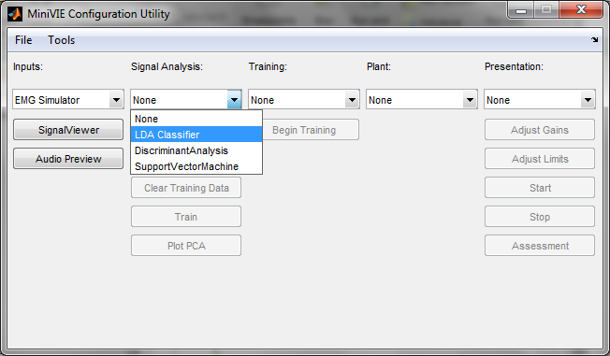
- Under Training, select Simple Trainer:
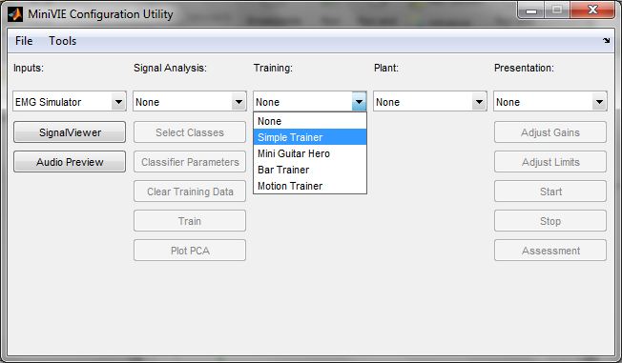
Note: Do not select any options for Plant or Presentation drop-down menus prior to beginning training.

- Select the desired settings for simple training when the dialogue box opens.
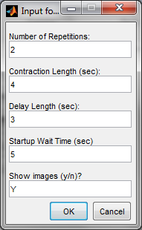

- Next click on the Select Classes button and a new window will open:
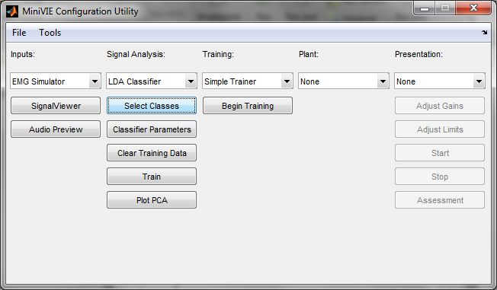
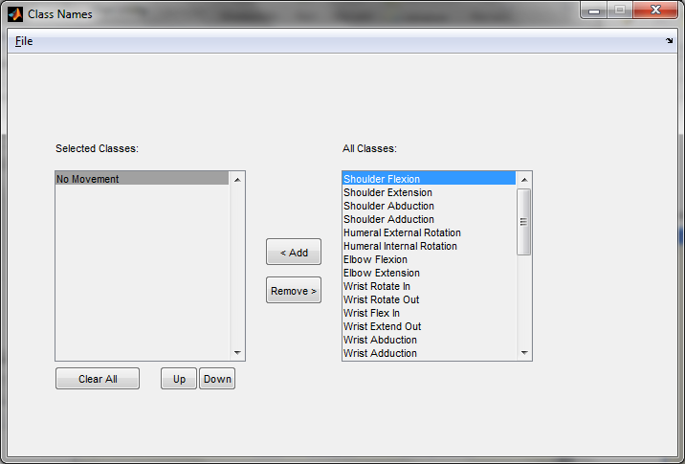
Note: Each class selected is a movement the arm will perform. Using the EMG Simulator, a maximum of 8 movements can be selected at a time. In addition to the 8 movements, “No Movement” should also always be selected so there is a baseline for each training session.

- Select the classes that are to be trained. Then close the window:
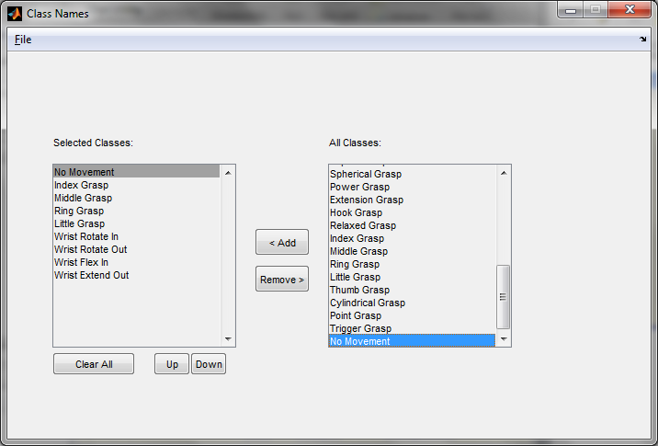
Section III: Training
This section goes through step by step of the training process. Before beginning the actual training process, the user should read the entire following section to understand the required actions of the user during the rapid training process.
Note: Record ahead of time (for future use in the MiniVIE demonstration) which key the user will assign to each movement class.
- A window will pop up with a 3 second countdown:
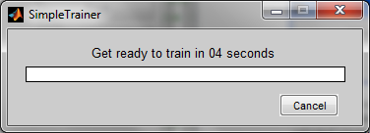
Note: as soon as the countdown begins, the user must select the EMG Simulator window (window should be maximized and click on this window to highlight it as the selected window). Keep this as the selected open window for the duration of the training process.
- The Trainer will then begin training with the first of the 8 selected classes. There will be a period of a few seconds (represented by a red loading bar) allowing for preparation:
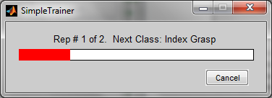
- During this time, press and hold down one of the designated 8 keyboard keys (a, s, d, f, q, w, e, r) which will later be assigned to the selected class. The Current Pattern will change pattern number. Continue to hold down the selected key and do not release the keyboard key throughout the next step:
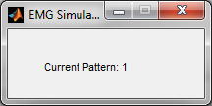

- The bar will then change from red to green and retreat to the left. During this time, the trainer program is collecting a signal from the selected keyboard key and matching that signal to the command being trained:
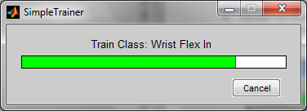
- When the data is collected, the training will transition to the next class. During the preparation period, switch the keyboard key selected (ie., release the first key chosen, and choose another of the remaining 7 key options). This should be represented by a change in the Current Pattern number:
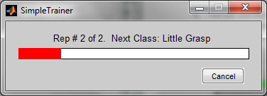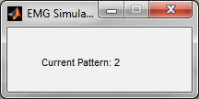
- Hold down the chosen keyboard key until the training for the current class is complete:
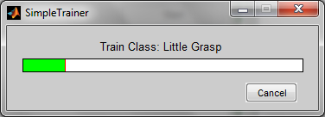
- Repeat steps 4 - 6 for the remaining classes, except for the “No Movement” class.
- For the training of the “No Movement” class, do not press any keyboard key:
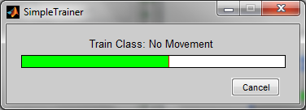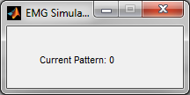
Note: The reason for not depressing a key during the “No Movement” class is that during the demonstration, the object (the arm for the MiniVIE demonstration) will remain still while it is not receiving signals. Otherwise, the user would have to hold down a key to keep the object still.

- Training is now completed:
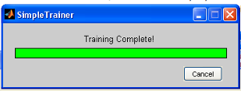
- When prompted with the window below, save the data gathered in this training session:
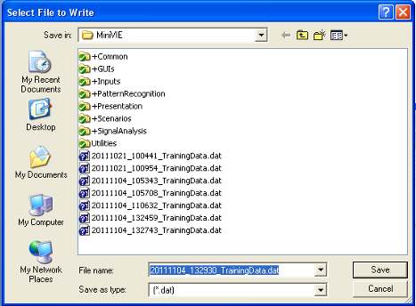
- Open the MATLAB window. In the MATLAB Command Window, the accuracy of the results from the training session is shown. Check the results and if they are not 100% for each command, return to step 1 and perform a new training session:
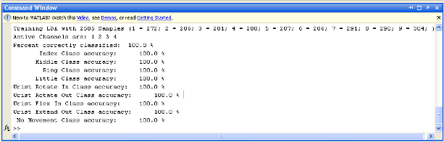

12. Once the user has read the training instructions above, select Begin Training in the MiniVIE Configuration Utility window:
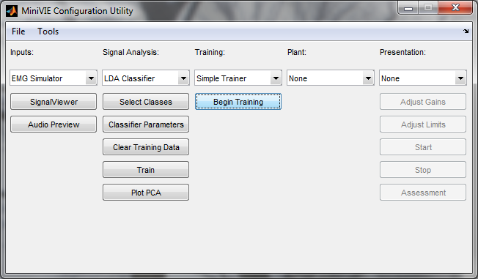

Section IV: Running the MiniVIE Demonstration

This section explains how to run the MiniVIE Demonstration once training is complete.

- Return to the MiniVIE Configuration Utility window, and in the Presentation drop-down menu, select MiniV. A window with an animated human arm will open:
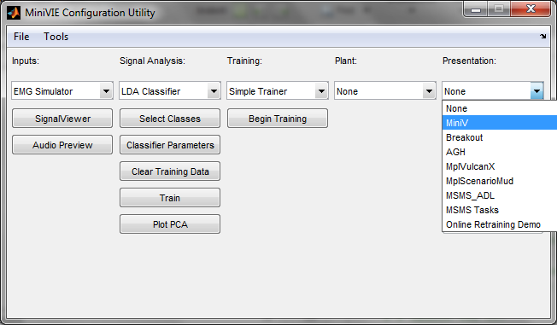
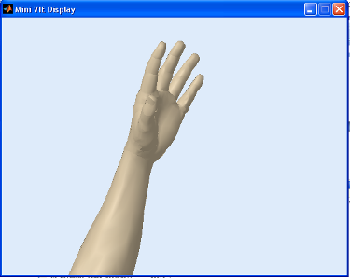
- Select the EMG Simulator window.

- Press one of the 8 keyboard keys associated with the eight movement classes:
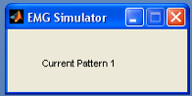
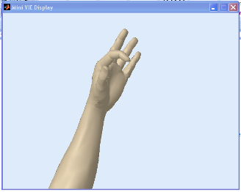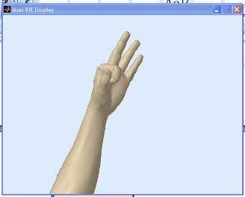
- Repeat step #3 with each of the remaining movement classes, to verify that the animated arm responds as expected to each of the command.

Note: In the MATLAB Command Window, the movement class that appears in real-time during the demonstration simulation, reflects the key currently being depressed (which was assigned during the training process to that movement class):
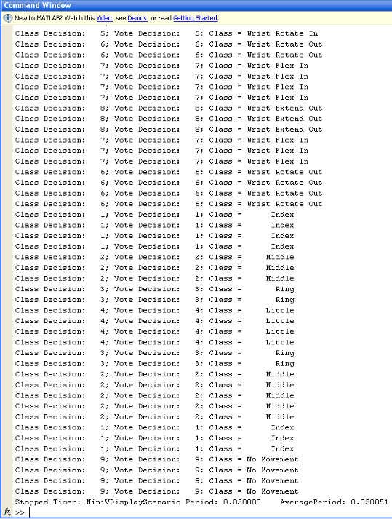
- To end the demonstration, exit out of the MiniVIE Display window.

Appendix A: Setting up Measuring Computing DAQ
Note that this DAQ must be used with MATLAB 32 bit

- Download the MCC DAQ CD
- Plug in USB-1208FS
- Open InstaCal and select configure(hand on circuit board icon)
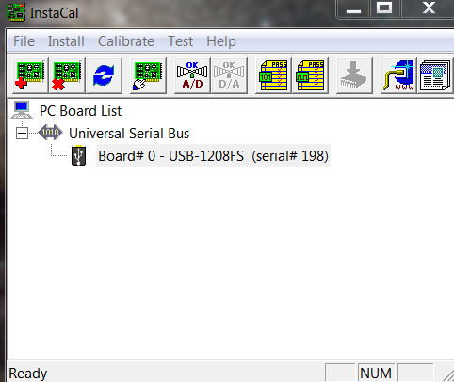
- Under No. of Channel, choose 8 Single Ended
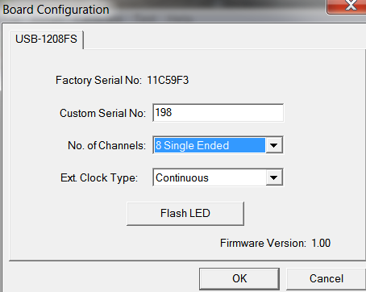

Appendix B: Setting up Limits and Reversing Joints
This section explains how to limit the range of motion for the joints and reverse their direction of motion.

- In the MiniVIE Configuration Utility window, select the Adjust Limits button.
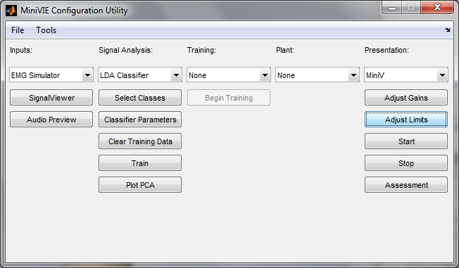

- A new window will open showing the current angle limits for each joint
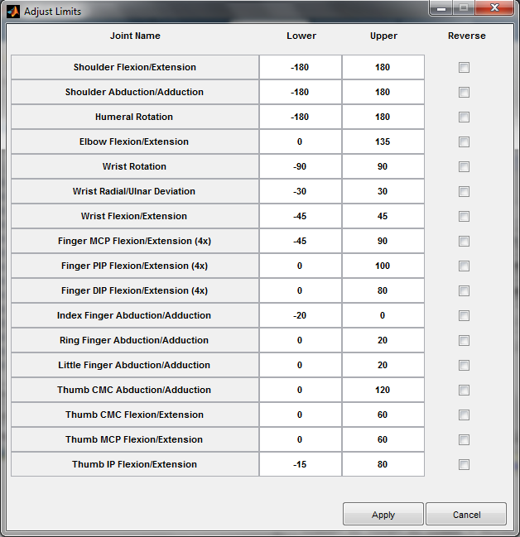

- To change a limit, type a new number into the box.
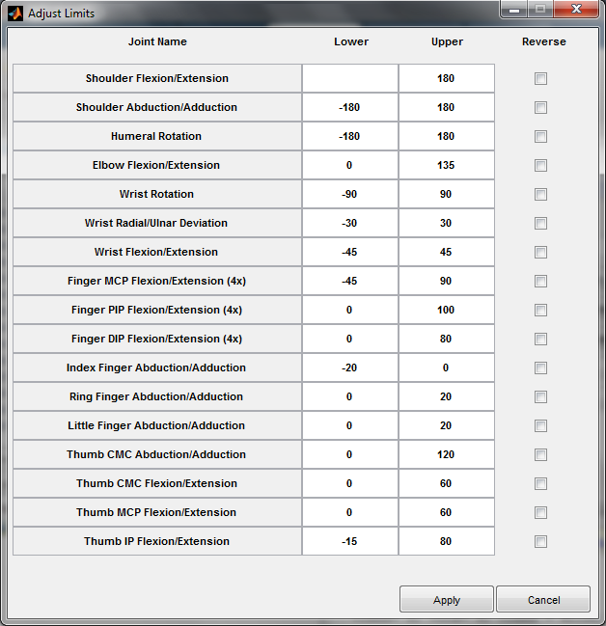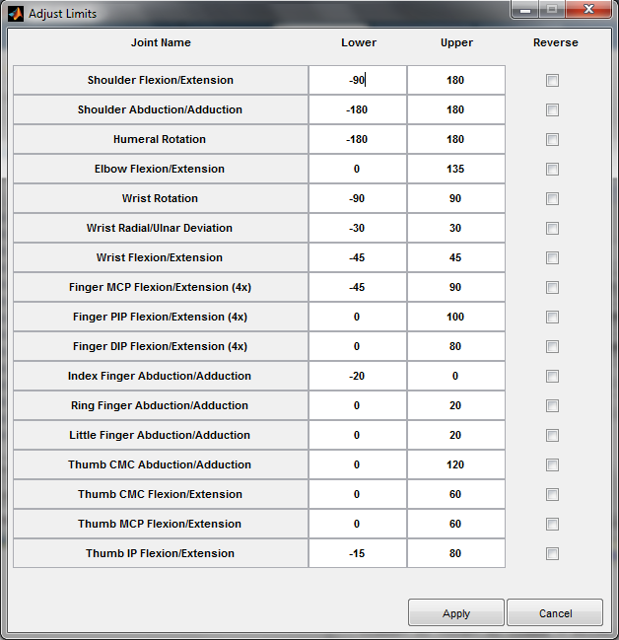

- If a joint acts in an opposite direction as desired, it can be reversed by checking the Reverse box
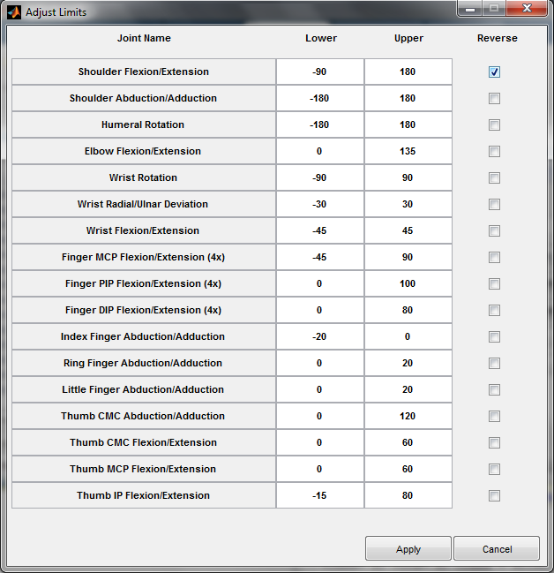

Note: reversing a joint or changing a limit will not occur until the apply button is selected
